Abdul Rasheeth, Abdul Latheef (Cognizant)

451083

Abstract

API Implementation

Project Management

Full Stack Engineer

Contents

1. User 2

1. Add new User 3
2. Save user 3
3. Search User 4
4. Sort (First Name/Last Name/Employee Id) 4

2. Project 6

1. Add Project 6
2. Search Manger in Project 7
3. Save Project 8
4. View Project (Search) 9
5. Sort Project (Start Date, End Date, Status, Priority) 10

3. Tasks 12

1. Add Task (Parent) 12
2. Search Project 12
3. Save Project 13
4. Add Task (Sub Tasks) 14
5. Search Project 14
6. Search Parent Task 15
7. Assign Tasks (search User) 15
8. Save Tasks 16

4. View Tasks 17

1. Default View 17
2. End Tasks 17
3. Sort View 18
4. End Task 18
5. Priority 19
6. Status 19

# POST: /api/users

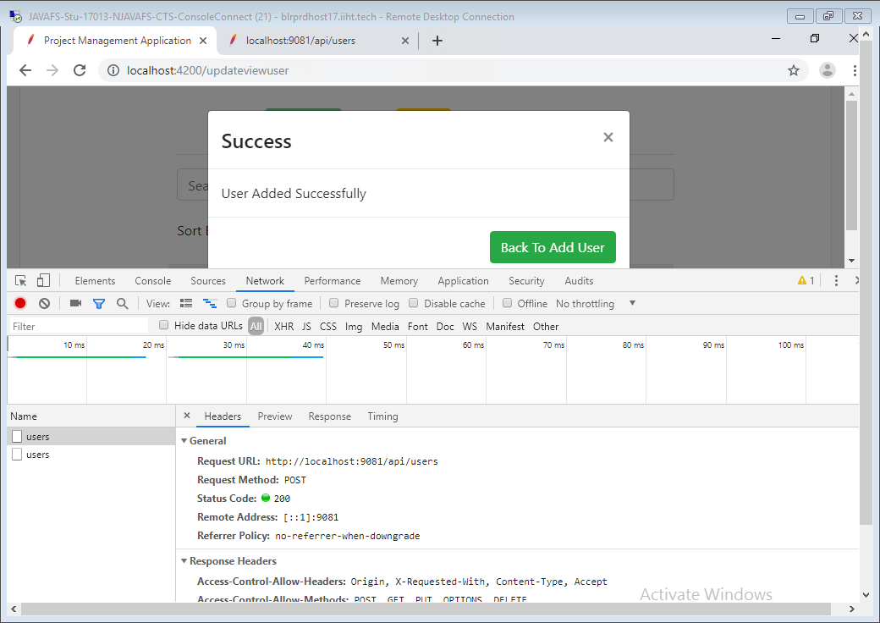

# GET: /api/users

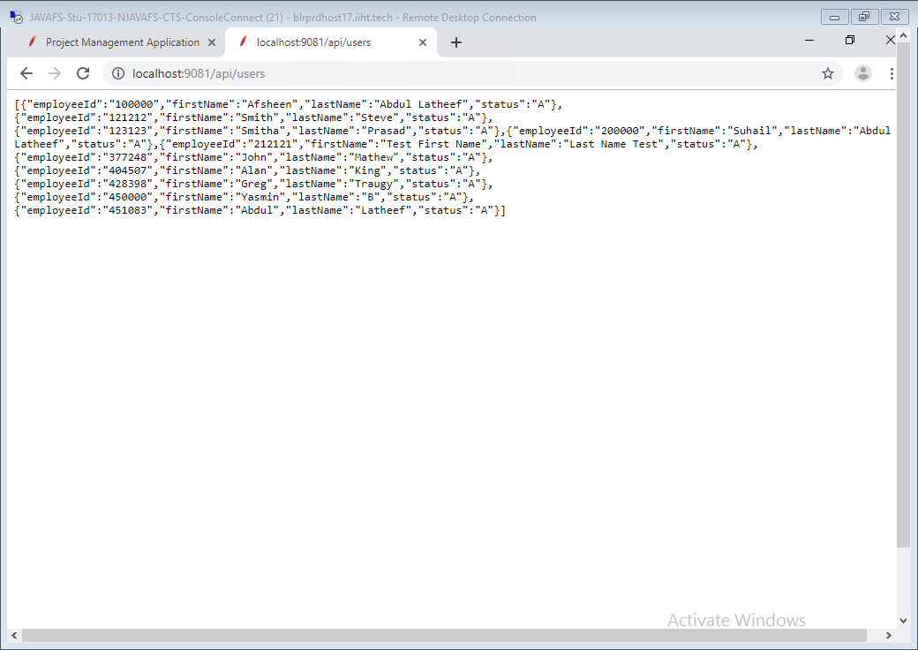

# /api/projects

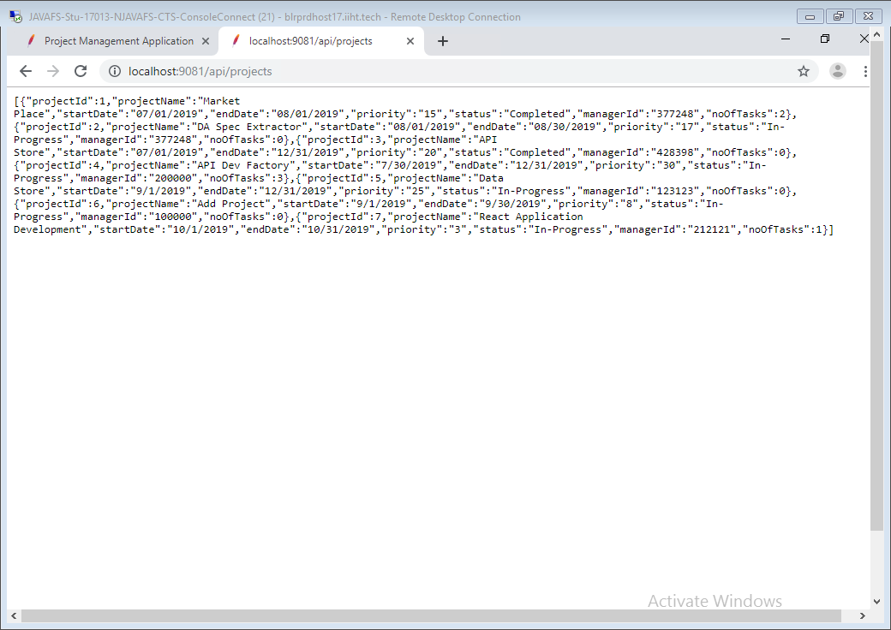

# /api/viewtask

